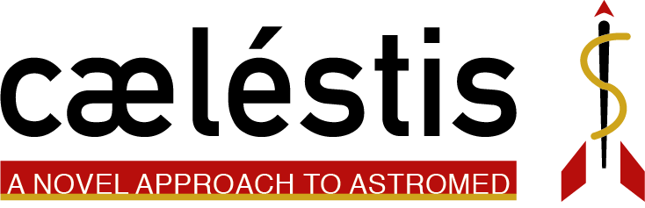

Suggested Additions to The Kit

Based on our research, the emergency medicine and traditional medical experience of our group members, as well as a deep perusal of the CHeCS Hardware Catalog (HMS), we find that there are some very critical items that are missing from current kits. These are based mostly on battlefield medicine that has been hard-learned in the last 10-20 years in Iraq and Afghanistan, as well as the deep understanding that even though there are multiple people on a space mission, there may be just one person left who is not incapacitated by a serious emergency.

These items are focused on stopping blood flow, reviving an injured crewmember, as well as giving the ability to a lone astronaut to perform emergency procedures in space.

The lone exception to this list is the UV irradiation machine. Paired with our 3D printed devices, it could extend the life of non-printable metal and ceramic items (blades, needles, etc…) significantly for a long-term mission.

|  |  |
| --- | --- |
|  | Israeli bandage – Specially designed, first-aid device that is used to stop bleeding from hemorrhagic wounds caused by traumatic injuries in pre-hospital emergency situations. |
|  | Bone IV – Also known as intraosseous infusion, this is the process of injecting directly into the marrow of a bone to provide a non-collapsible entry point into the systemic venous system. This technique is used to provide fluids and medication when intravenous access is not available or not feasible. |
|  | Instant Blood Clotting Kit – an antihemorrhagic agent is a substance that promotes hemostasis (stops bleeding) |
|  | Oral rehydration therapy – is a fluid replacement strategy used to prevent or treat dehydration, most commonly that caused by diarrhea. It involves drinking water with modest amounts of sugar and salt added, while continuing to eat. |
|  | Ultraviolet germicidal irradiation – is a disinfection method that uses ultraviolet (UV) light at sufficiently short wavelength to kill or inactivate microorganisms. |